EEM 322
DENETİM SİSTEMLERİ
Matlab Ödevi

Hazırlayan: A. Cihan ÖZÇÖREKÇİ
20294004 EEM
SORULAR:
*OGATA – B.8 (29)
*URAZ - 6.4 (a)

B-8-29

Root locus
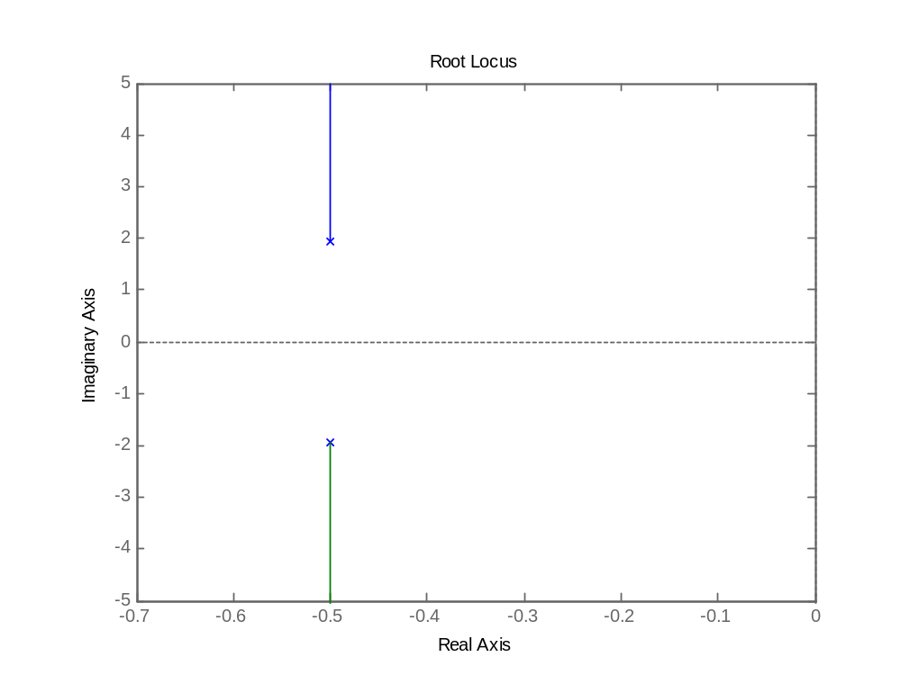
Nyquist
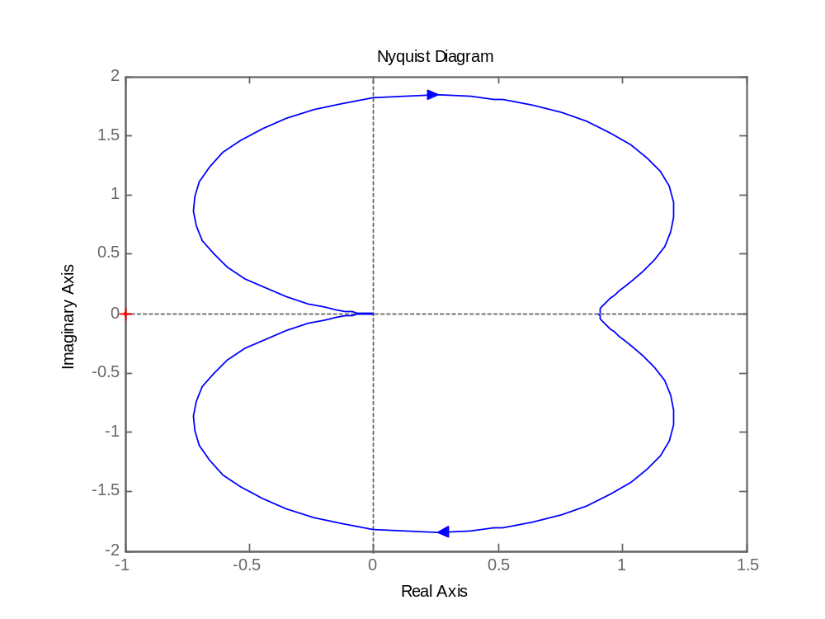

Bode
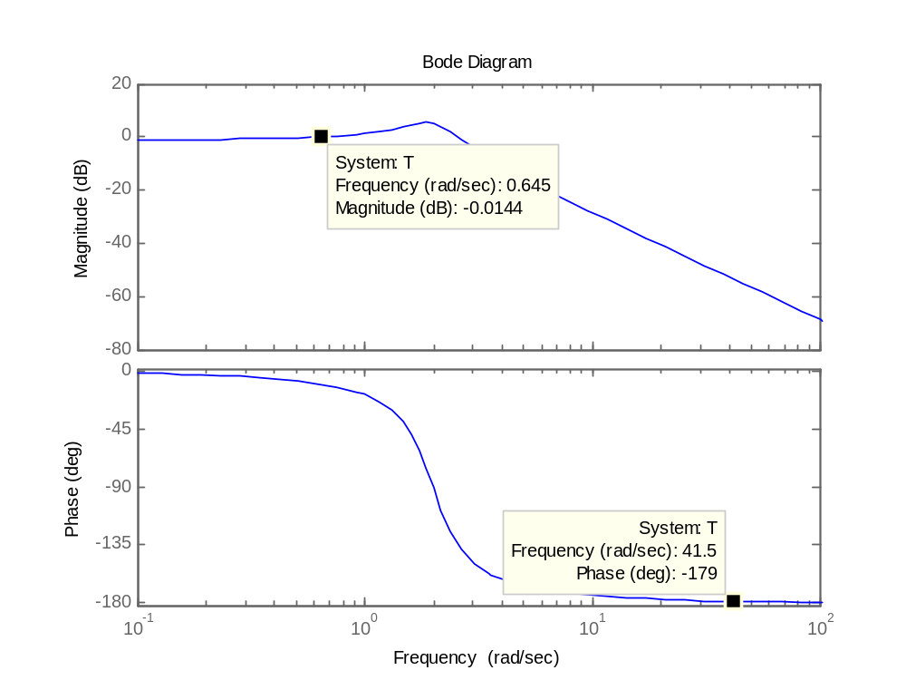
Step response
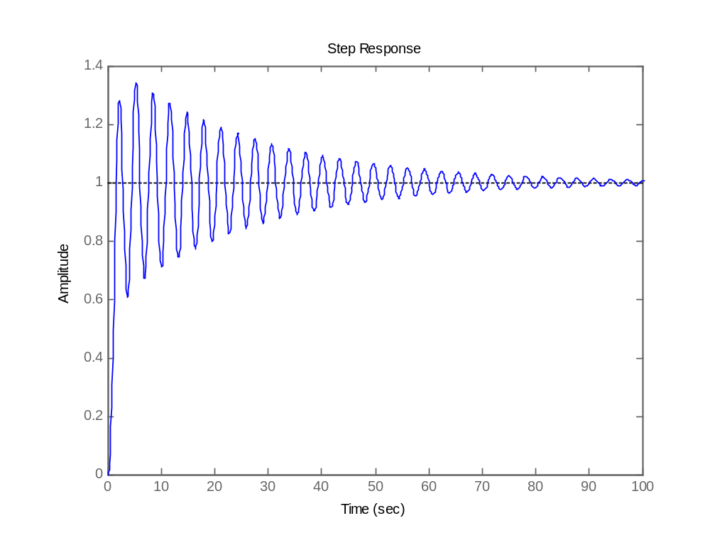

6.4(a)
rlocus
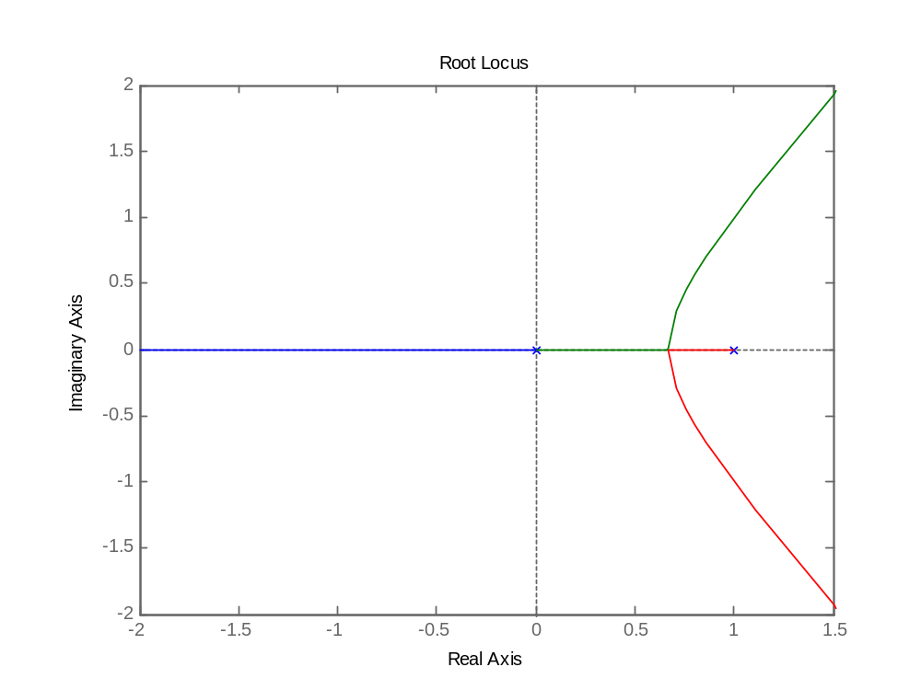
Nyquist
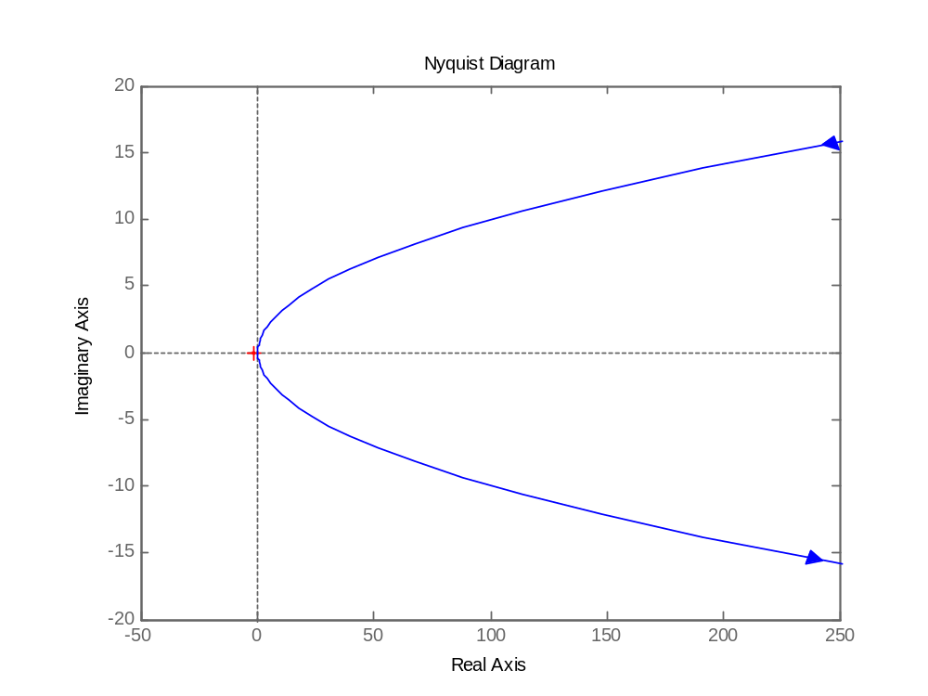

Bode
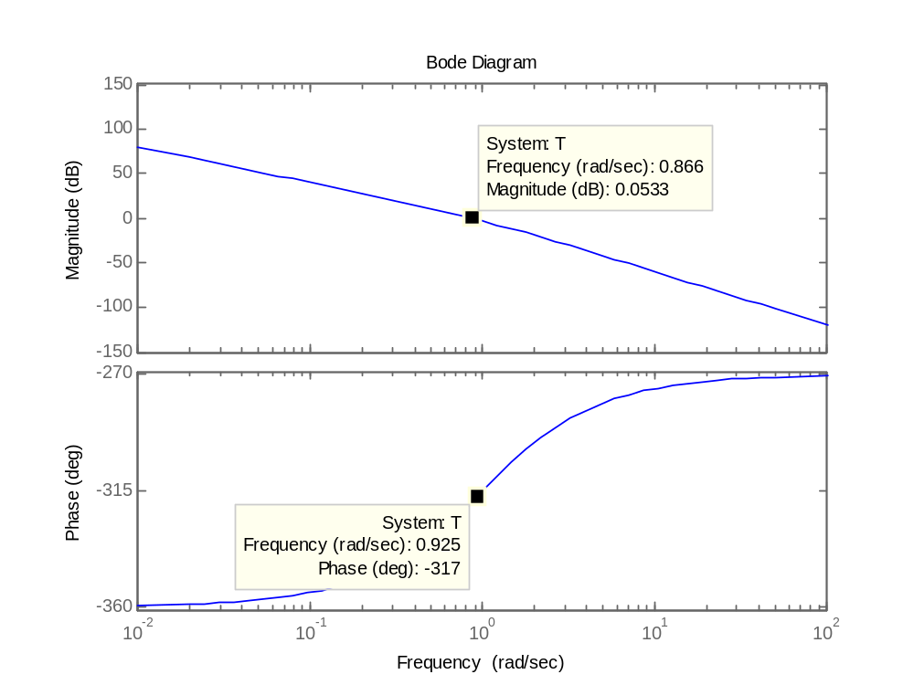
Step response
